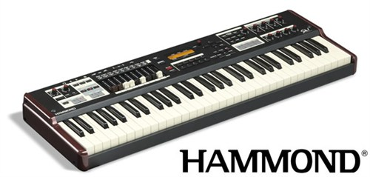

Hammond style:
https://www.youtube.com/watch?v=cnOgt0Y__zc
https://www.youtube.com/watch?v=zTJbeYRdEpo
https://www.youtube.com/watch?v=2i03yVUTE08
https://www.youtube.com/watch?v=gkIY3y5vuYw
https://www.youtube.com/watch?v=8RSkUW4hIxU&list=PLDD8EBD93CFA05E22

Jimmy Smith
https://www.youtube.com/watch?v=sxTbVzY5KTY&index=2&list=PLA4D9441CF33BFC22

Hammond emulator
http://bristol.sourceforge.net/hammond.html

